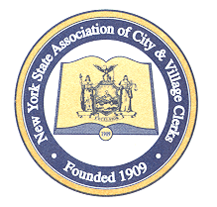

NEW YORK STATE ASSOCIATION OF CITY AND VILLAGE CLERKS

Membership Form

October 1st - September 30th ANNUAL DUES: $50.00 (per person)

*EACH MEMBER MUST FILL OUT THEIR OWN INDIVIDUAL FORM*
ENCLOSE WITH CHECK PAYABLE TO:

NYS Association of City and Village Clerks

RETURN TO: c/o Village of Rhinebeck
Attn: Martina McClinton, RMC
NYSACVC Treasurer
76 East Market St
Rhinebeck, NY 12572
________________________________________________________________

MEMBERSHIP INFORMATION

PLEASE PRINT

Municipality: ________________________________________
Name: _________________________________________
Title: _________________________________________
Address: _________________________________________
_________________________________________
Phone: ________________________
Fax: ________________________
Email: _______________________________

Please circle any certifications attained: CMC MMC RMC

New Member? Yes No

Replacing: _____________________________________________

I, Martina McClinton, do hereby certify that the items of the account are true and correct; that no Federal or State taxes for which the municipality is exempt are included; and that no part of the same has been previously paid. I can be reached at 845-876-7015 opt 3.

Martina McClinton, RMC Village Clerk
NYSACVC Treasurer

